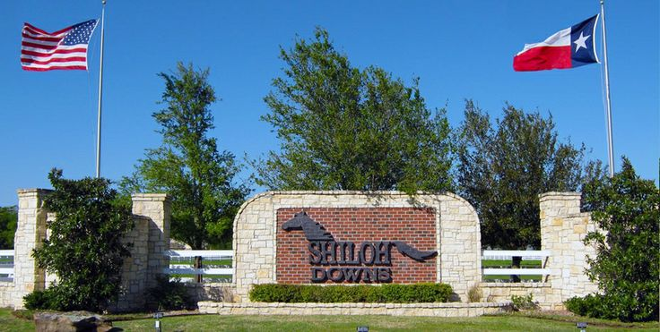

Shiloh Down HOA Red Oak, Texas

Your Community . Your Voice

November Newsletter

Newsletter

November, 2018

**RECENT IMPROVEMENTS:** On September 28th a portion of Pedigree received a much needed road repair which involved removing the previous asphalt repairs and forming one continuous paving area with smooth transitions between concrete and asphalt in lieu of the previous spot-patch efforts. The repair cost was approximately $12.500.00

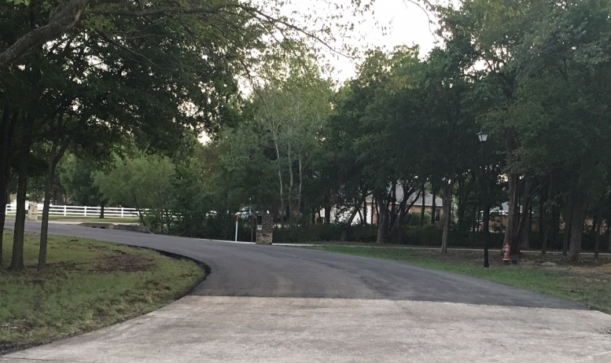

We all realize this is not a permanent repair (concrete) but due to budget restrains the Board felt this was the best use of our current resources.

A new internet site has been created just for Shiloh HOA owners. [**https://www.shiloh-downs-hoa.com**](https://www.shiloh-downs-hoa.com)

There are several internet sites created by the developer for marketing purpose only; however the new site is designed with you, the owner in mind. It describes who we are, where were located, contains some of our past News-Letters, Minutes, Bylaws and Declarations etc. It will become our new electronic historical record keeping system. If you couldn’t make the last annual meeting for some reason, well, instead of asking your neighbor for second-hand information, just go the site and open the Minutes. One caveat is that, it is a work in progress, so, if you see something that is incorrect or think of a way to make it better, then use the ***Contact Us*** page which can be used not only for the internet site but any other questions you might have about your HOA.

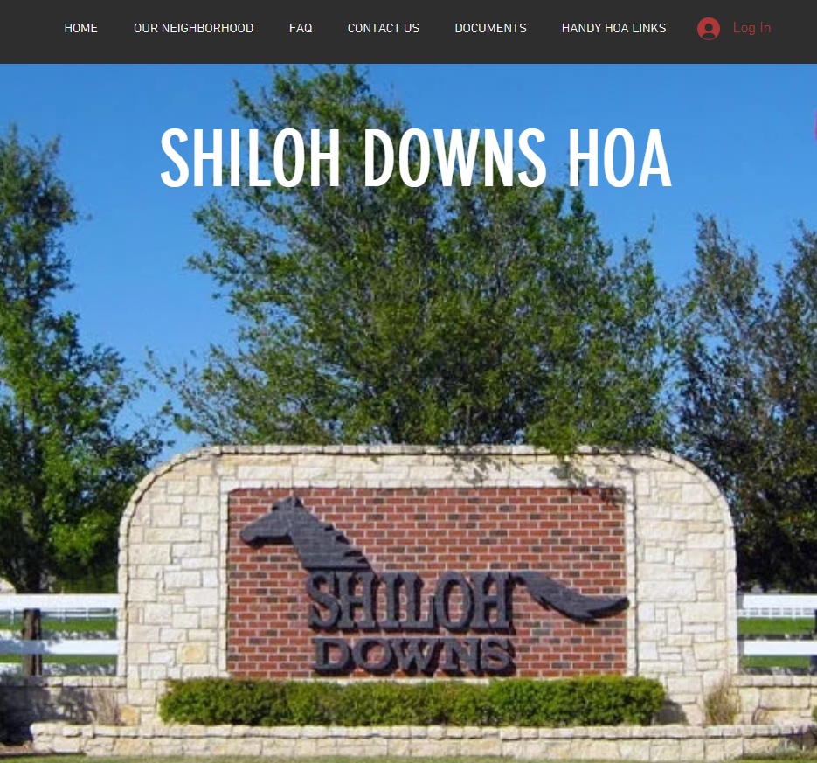

The HOA Board is interested in hearing what you have to say to help make the community a premier and safe community.

In regards to safety, with the recent thefts in our community the HOA Board is reviewing possible replacements to the gate system. Until that is accomplished be mindful that while we live in a gated community, a determined thief won’t always use the road to access your property. Keep your garage/building doors down, check your security lights, cameras etc. to ensure they are working properly and above all if you have **anything** stolen, report it to the Ellis County Sherriff’s Dept. or Texas Highway Patrol. (See **HANDY HOA** **LINKS** on the new web-site) Your HOA Board has made contact seeking extra patrol for our area but since most of the thefts were not reported they (Ellis County Sherriff’s Dept.) doesn’t see this as a neighborhood that warrants extra patrol, not to mention that there are only a few Sheriff Officers for the entire County.

As of November 7th 2018 there are **no** remaining lots to be sold! All 58 lots are now individually owned and folks are building & moving in as you read this letter. With that update the only remaining land advertisement sign was updated to reduce traffic flow in our neighborhood from folks who “may” have wanted to purchase acreage.

**Before and After:**

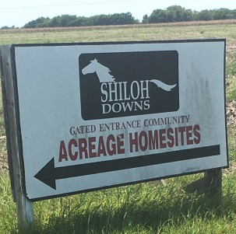 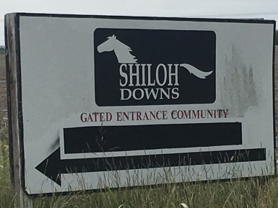

Making a community great takes more than talk, it takes people who do!

Most of us have heard that in a typical church 10% of the people does 90% of the work. That shameful percentage is dropping as we see less volunteering, which leads to greater operating cost and often at a lesser quality because pride has been replaced with a dollar. Volunteers who once cleaned the church, mowed its lawn and took care of everyday maintenance are gone, leaving a void that has forced most churches to hire out those efforts, thus increasing the cost of “running the church”. There are obvious differences of running a church vs. an HOA but in the area of volunteering vs. cost it’s the same analogy.

We recognize that most of our owners are employed which consumes a significant portion of your day but, like the church, each one of us already have a significant vested interest here at Shiloh Downs with unique skills and talents that can enrich your community if, we will just give a little of our time/energy away. We are better when we team-up together. **You can make a difference**, and that’s not a cliché, it’s the truth. Please consider one of our current positions and how you could serve in the following areas:

* Vice-President
* Safety Committee (not to be confused with law enforcement).
* Architecture Control Committee
* Landscape Committee
* Social Committee
* Communications Committee

Regardless if you can or cannot serve, please continue to send us your suggestions for review.

All suggestions/recommendations will be evaluated to determine if it is something that can be implemented. Please note that we cannot implement EVERY suggestion as we are often limited by our resources but, someone will provide feedback.

**Communication:** In an effort to use what has become an everyday tool for most of us, all future notices will be delivered by email. Please be assured that we will be sending all such mailings using the blind delivery option to maintain your email privacy. In doing so, we reduce our delivery efforts and the mailing cost. If you feel that you missed something you can always reference: [**https://www.shiloh-downs-hoa.com**](https://www.shiloh-downs-hoa.com)

**If you wish to continue receiving your notices by U.S. mail then please write to:**

Shiloh Downs HOA

P. O. Box 1542

Red Oak, TX. 75154

**FISCAL REVIEW**:

**Delinquent Accounts:** As of November 7th, 2018 the amount **of $13,522.55** owed to the HOA is delinquent.

Please keep in mind that if you would like to see the community continue to grow and develop, EVERYONE is expected to pay their dues on time. Payments are due the 1st of each April and October.

We all know that it takes money to run this community and for those who do pay promptly and on time we say thank you, for doing what you agreed to do. You are to be commended, for your word is backed up by your character and taking responsibility for what you agreed to do.

Dues are used for neighborhood improvements, ground/irrigation maintenance, street repairs, and also for special projects to improve the community. For special payment options or additional information regarding the delinquent dues please contact us.