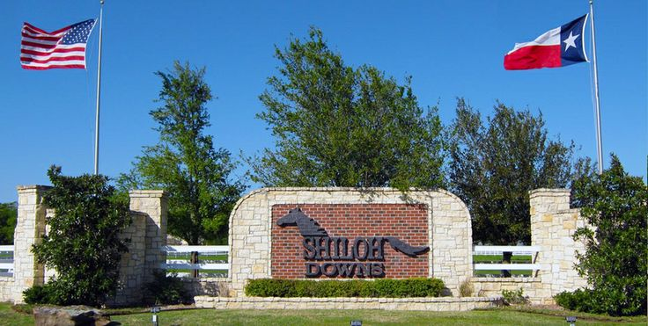

Shiloh Down HOA Red Oak, Texas

Your Community - Your Voice

March Newsletter

Newsletter

March, 2019

**RECENT IMPROVEMENTS:** This past fall with the record rains the pond on the East side of Sidewinder loop dam broke causing major erosion downstream to the property.

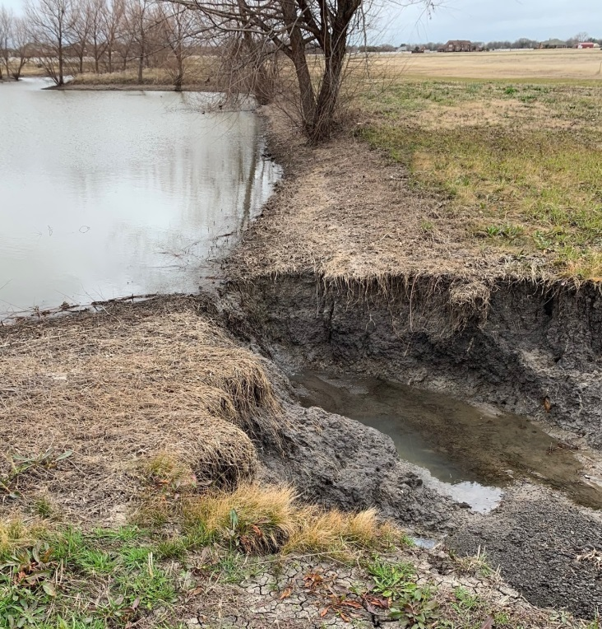

A contractor was hired to repair the damage until the land dries up enough to sustain the weight of a back-hoe on top of the dam area. The back-hoe will dig out a portion of the dam and install a overflow drain pipe, allowing for a more controlled removal of the water without damage to the dam or downstream property. The completed efforts came in at $2000.00

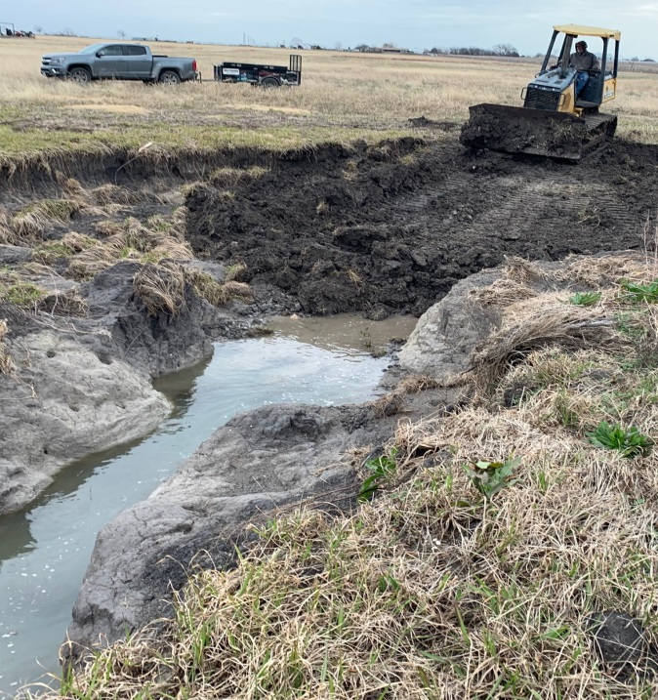

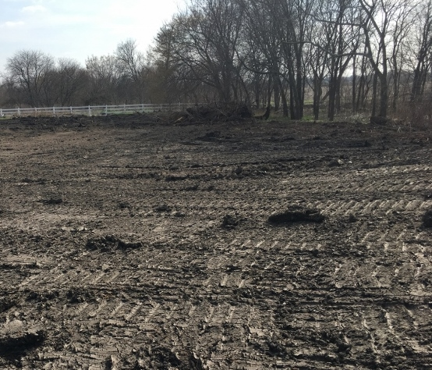

In the ***November Newsletter*** 2018 we informed you that we were reviewing possible replacements to the gate system. On February 20th, 2019 the much needed upgrade was completed to the gate entry system. The system will allow us to finally shut down the gate on a permanent basis. It provides personal home codes and a modern App for easy access. The upgrade came at a cost of approximately $6558.00

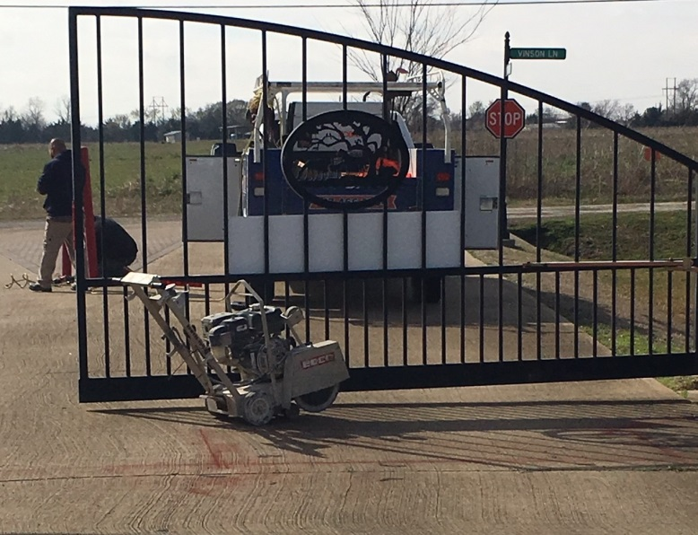

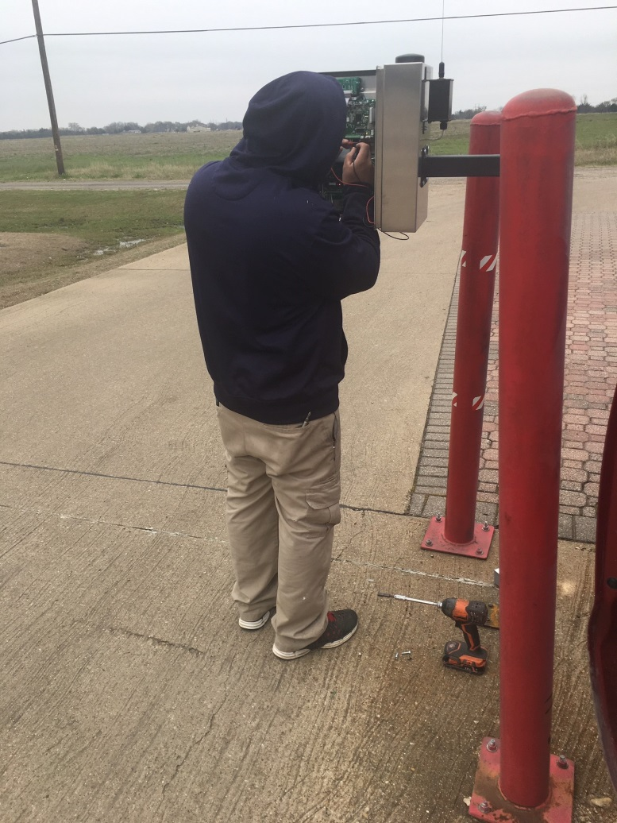

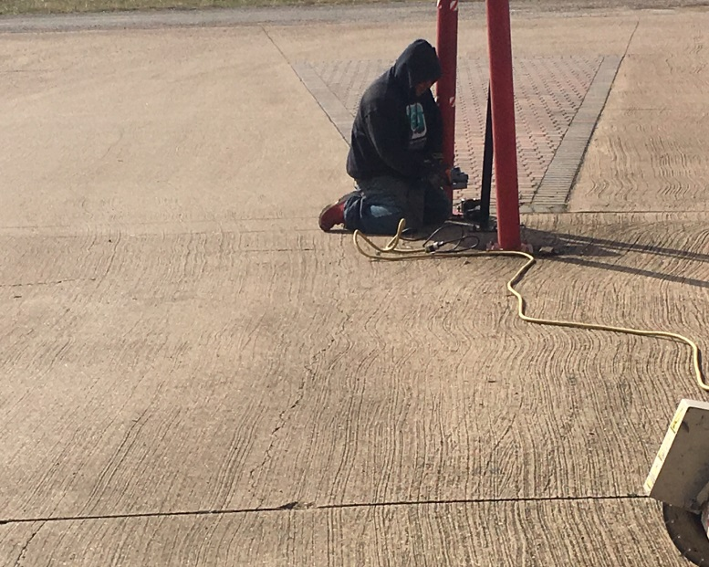

**ANNUAL BLOCK PARTY**

**SAVE THE DATE!**

ARE YOU NEW TO THE NEIGHBORHOOD?

ARE YOUR NEIGHBORS SORT OF LIKE STRANGERS TO YOU?

DO YOU LIKE TO FELLOWSHIP OR EAT?

Boy, are you are in luck!

It’s that time again where we dust off the recipe books and show off our best desserts and entries. Block parties are more than just about eating good food; they are also about connecting with your neighbors.

If you have moved here to Shiloh Downs in the past 12-15 months don’t miss this time of food and fellowship so save the date – **April 6th from 3 -6 p.m.**

**HELP NEEDED**

Making a community great, takes more than talk, it takes money of course but just as importantly it takes people who help with the day to day operations.

All of us who live here would agree that we are blessed to be here. But beyond the “blessing-factor: it’s also because of your hard work ethic, talents and abilities that made it possible.

It’s that work ethic and ability to see what needs to be done and help make it happen that we need. Please consider investing beyond the home you live in to the people we call our neighbors and our community. Please consider serving one of the following areas.

* Vice-President
* Safety Committee (not to be confused with law enforcement).
* Architecture Control Committee
* Social Committee
* Communications Committee

**FISCAL REVIEW**

**DELINQUENT ACCOUNTS:** As of March 1st, 2019 the amount **of** $6,431.64owed to the HOA is delinquent. **All** Members (except one) are up to date on their dues.

As you can see, your dues are used way beyond the normal expenses such as utilities (water/electric) and mowing. They include upgrading neglected and out of date systems such as the gate and soon the irrigation system will receive a more automated upgrade as two of the round-about don’t have working timers and several stations are not working. They are currently being turned on/off manually. We are in the process of receiving bids for a solar powered, automated irrigation system as you read this.

**Note:** In an effort to be transparent and yet limited to our Members viewing only, the budget is not published on our internet sight but is available to any Member to review upon request.

**COMMUNICATION**

Regardless if you can or cannot serve, please continue to send us your suggestions for review.

The HOA Board is always interested in hearing what you have to say to help make the community a premier and safe community.

All suggestions/recommendations will be evaluated to determine if it is something that can be implemented.

Please note that we cannot implement EVERY suggestion as we are often limited by our resources but, someone will provide feedback. [**https://www.shiloh-downs-hoa.com**](https://www.shiloh-downs-hoa.com)